**Outdoor Multisport Scoreboard BT2045 Alpha**

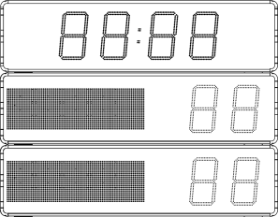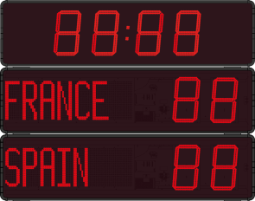

**The outdoor digital scoreboard shall display the game clock, the teams’ names and each team score.**

The scoreboard shall be able to manage, as a minimum, the following sports: football, rugby, beach soccer, beach volley and field hockey.

* ***LED technology***
* High luminosity LED technology shall be used to ensure proper readability in all outdoor light conditions and provide a viewing angle of 160°.
* The luminosity level of the red LED display shall be adjustable from the controlling keyboard at any time during the game.
* ***Game clock and scores***
* The game clock and the scores shall be displayed with 45cm digits and shall be readable from as far as 200m.
* A four-digit game clock shall display minutes and seconds, be capable of counting up or down and, when the game is not in progress, be able to display the local time and optionally the temperature.
* The teams’ score shall use a two digits display capable of displaying scores from 0 to 99.
* ***Teams’ names***
* The teams’ names shall be digitally displayed and contain at least 10 characters whose size shall be automatically adjustable.
* The names shall be programmable from the control keyboard.
* ***Technical characteristics***
* The scoreboard shall have a weatherproof aluminium casing rated no less than IP54 for outdoor use and equipped with a transparent shockproof protective front cover providing an IK07 rating.
* For an easy access to all components the front cover shall be removable by sliding out of either side.
* Tropicalized electronics shall be required in order to guarantee reliable outdoor operation in temperatures ranging from -20 to +50°C and in high humidity conditions.
* The scoreboard shall be powered by a 230V, 50/60Hz mains.
* The scoreboard shall weigh no more than 90kg while measuring approximately 2400mm x 1900mm x 85mm.
* A multisport digital keyboard shall be used to control the scoreboard via cable or radio signal.

*The power capability of the 230V power source provided by the installer shall be no less than 240W.*

**Required accessory**

* ***Multisport digital keyboard***

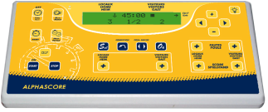

* ***Technical characteristics***
* The communication between the keyboard and the scoreboard shall be accomplished through either cable or 868MHz HF radio.
* The keyboard shall have a 2-line, 20 characters/line LCD display.
* A 100-240V/15V power adapter shall be supplied to power the keyboard.
* A backup battery shall be integrated to the keyboard to provide approximately 8 hours of autonomy.
* The keyboard shall be able to be used indoor or under shelter.
* ***Keyboard functions***

The digital keyboard shall be able to perform the following operations:

* Sport selection and configuration,
* Enter the Team’s names
* Start a new match,
* Reset the game clock,
* Start and stop the game clock,
* Increment and decrement the Home and Guest scores,
* Selection of the game clock counting mode: up or down,
* Selection of game clock display or local time display
* Adjustment of the scoreboards luminosity,
* Time setting,
* Turn ON and OFF an optional horn.

**Options**

When post mounting is required, posts sized and designed to face the local wind conditions shall be available.

A solar power supply shall be available as an option to power the scoreboard.